How to Modify your PSG Registration
- Go to the Reg Online System by clicking on the link below:
http://www.regonline.com/psg2016
Click on Register Now button on the upper right.
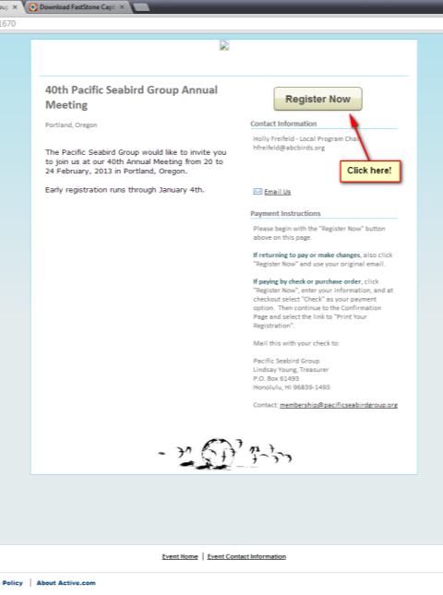
- Click on the View or Change Your Existing Registration.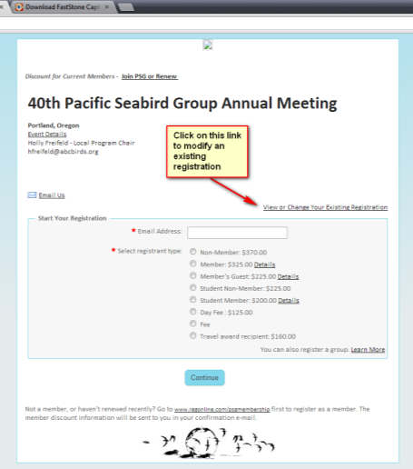
- Enter the email address you used in your original registration.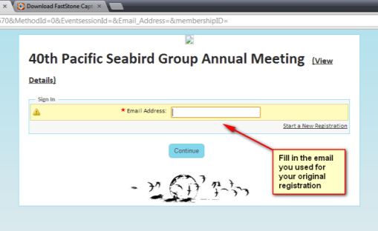
- An email will be sent to your email with a link to change your registration.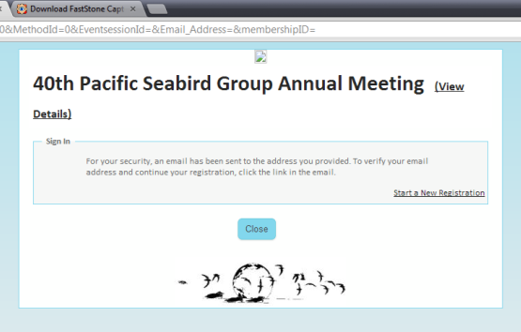
- Go to your email, and click on your unique registration link.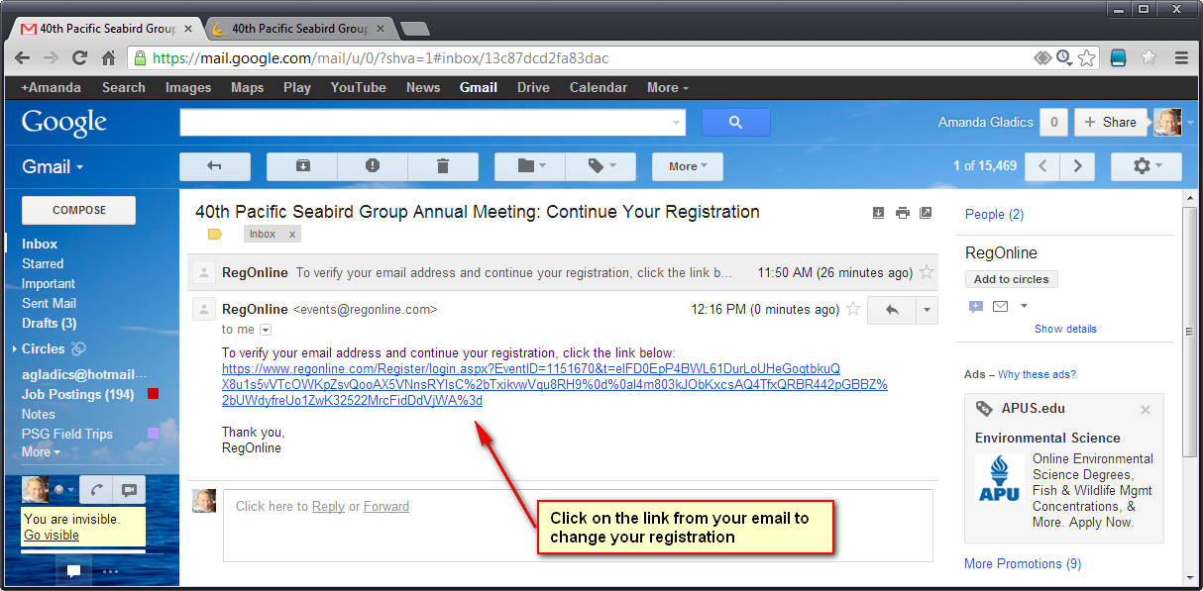
- Click on Continue.
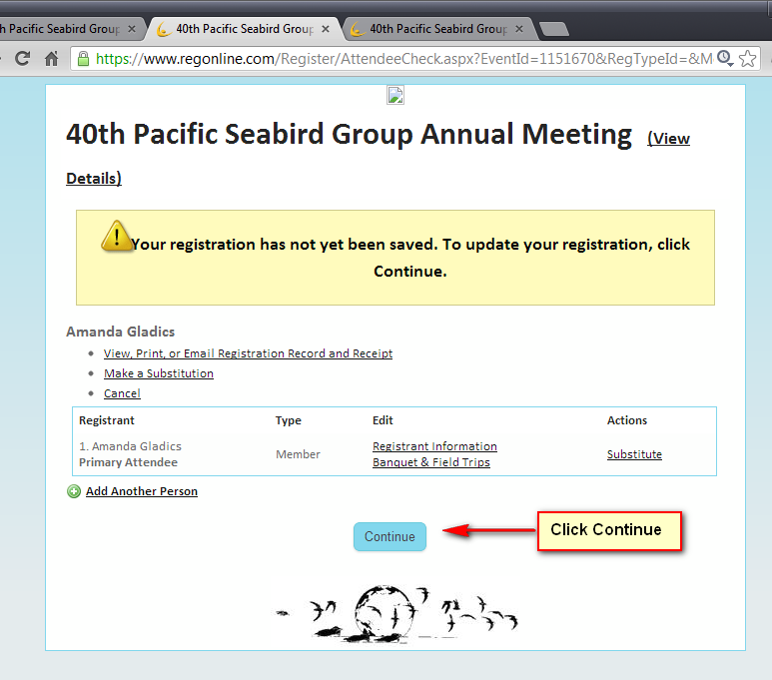

- If you would like to change your registration, go to the “agenda” header; if you would like to add a field trip or merchandise, go to the “banquet and field trips” header (what you see below). Once you have made the changes to the page your are editing, click Continue at the bottom of the screen.
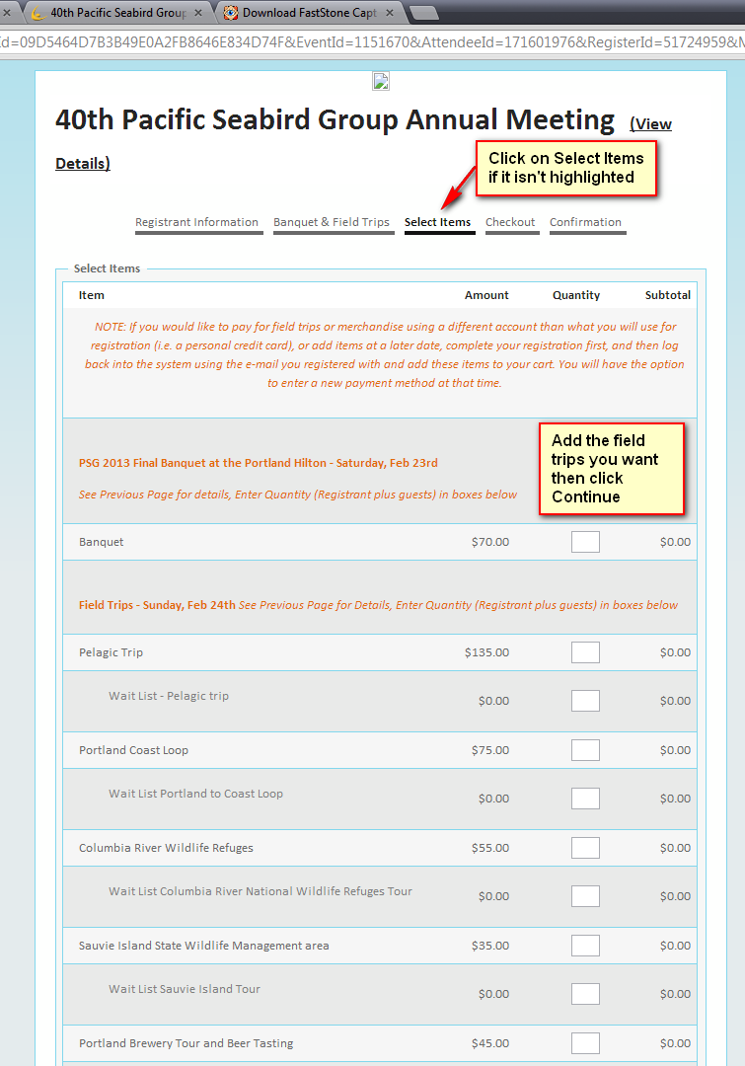
- Finish your checkout and click Finish. You will get a confirmation screen and a confirmation email that will show your registration changes.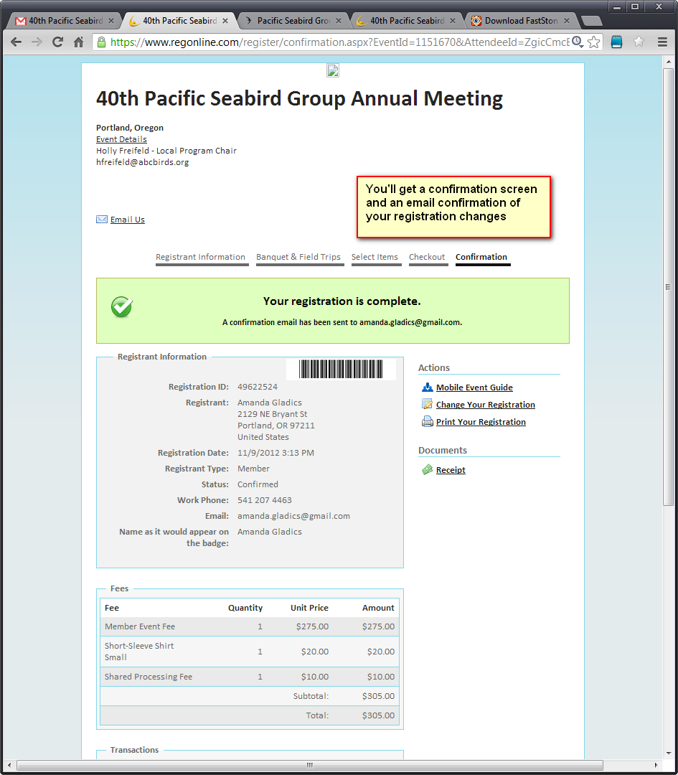
- Congratulations! You’re done! You can follow the same steps to modify your registration as many times as needed.

